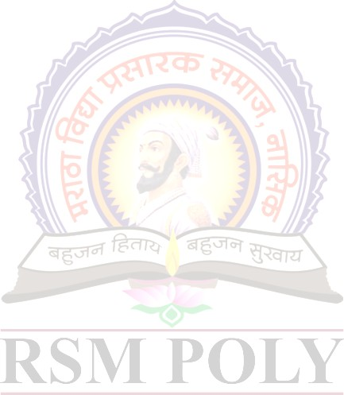

|  |  |  |  |  |
| --- | --- | --- | --- | --- |
| **TEXT EDITOR** | | | | |
| **Details of Student(s)** | **Enrollment No.** | | **Exam Seat** | **Name of Student** |
|  | 1910020362 | | 215646 | Savant Omkar Vitthal |
| 1910020363 | | 215647 | Sawant Diksha Pravin |
| 1910020364 | | 215648 | Shimpi Om Vilas |
|  | |  |  |
| **Project Guide(s)** | Prof. S.V.Sarode | | | |
| **Name of Industry** | NA | | | |
| **Nature of Project** | Application Base | | | |
| **Application(s) of Project** | Industry | | | |
| **Abstract:** This paper is scrutinizes the use of different concepts of packages and interfaces in Advance Java  Programming, enabling viewer to get the complete concept of different aspects of Advance Java  Programming To satisfy this we have created a Text Editor program using Java. It is done by importing  packages and interfaces of various classes available in advance java its is also GUI based which is also  used as a reference to the output, satisfying every need of a perfect microproject. | | | | |
| **Introduction**: Java is a high-level, class-based, object-oriented programming language that is designed to have as few implementation dependencies as possible. It is a general-purpose programming language intended to let programmers write once, run anywhere (WORA).  We have created a Java text editor program using abstract windowing toolkit(awt), event handling and Swing packages and interfaces. We deeply understood the concepts of Advance Java, thanks to this project  topic | | | | |
|  | |  | |  |
| **Fig. 1: Output I** | | **Fig. 2: Output II** | | **Fig. 3: Output III** |
| **Competitions: NA** | | | | |